Angular Routing — Guards, Lazy Loading & Route Data
Task 1: Route Configuration, Parameters and Nested Routes
Goal: Set up all portal routes including dynamic segments and nested routes
app.routes.ts:
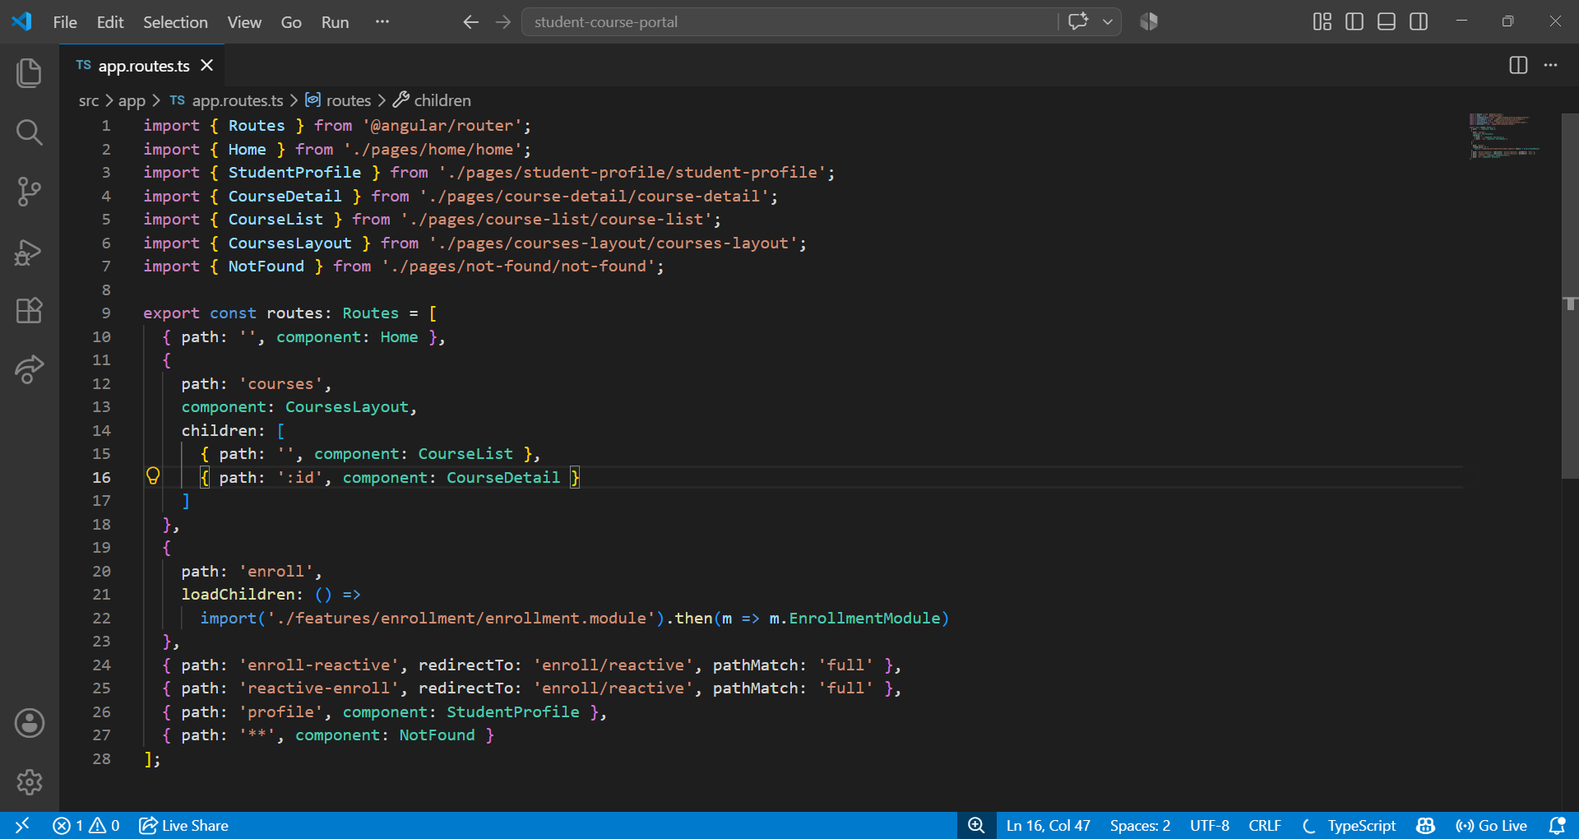
course-detail.html:
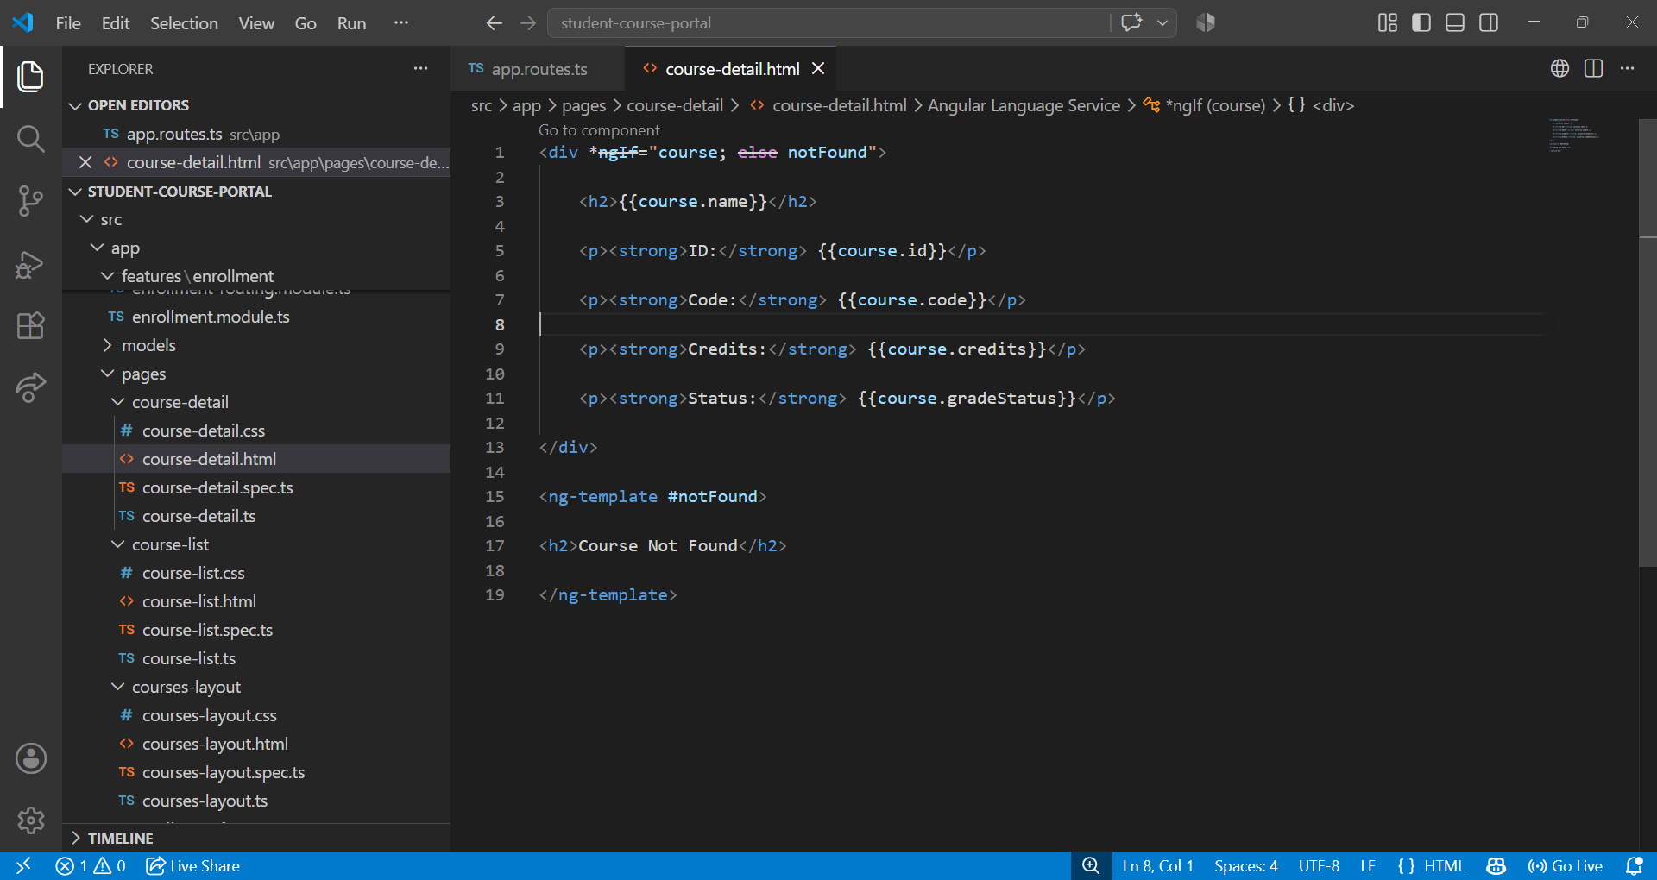

course-detail.ts:
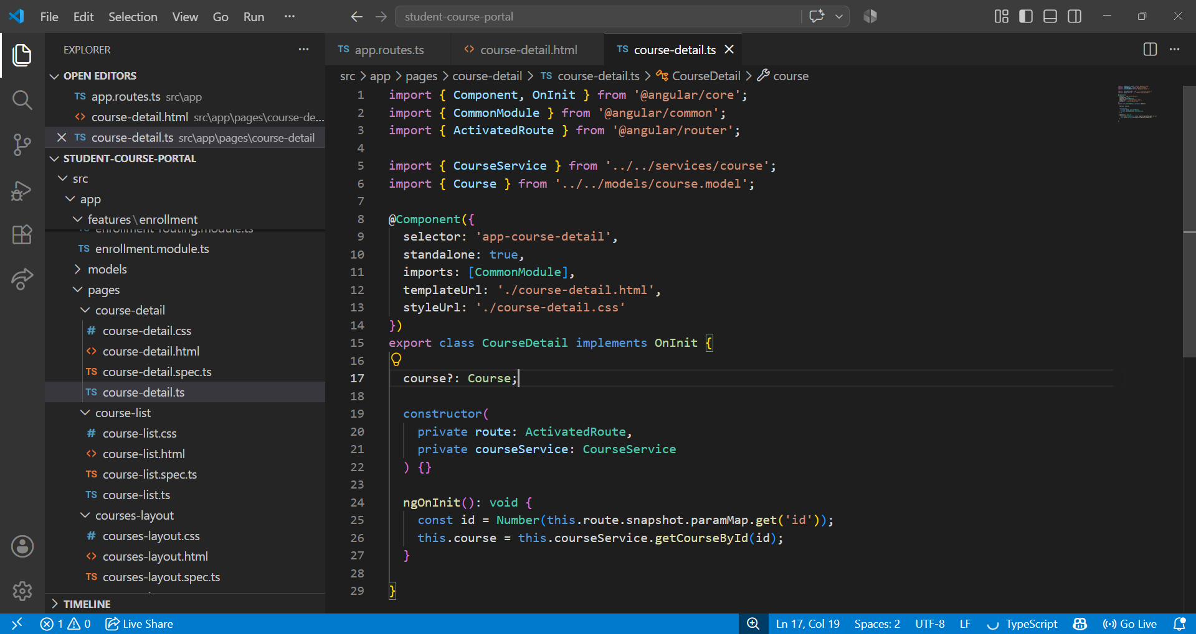
Getting Course with Id:
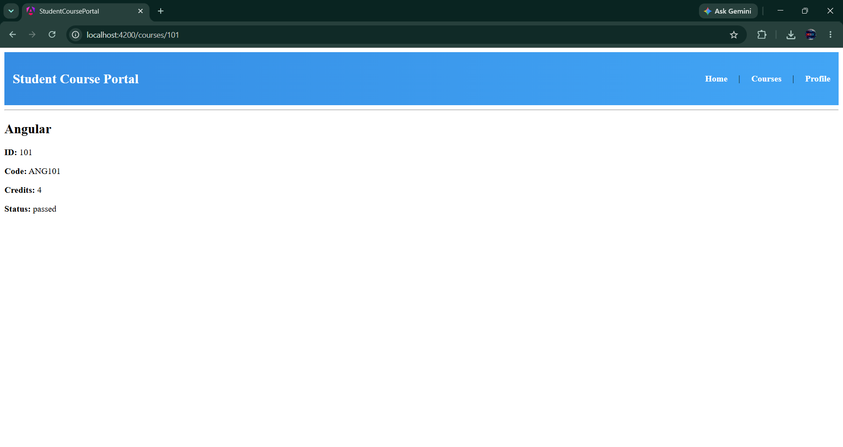

Course-list.html:
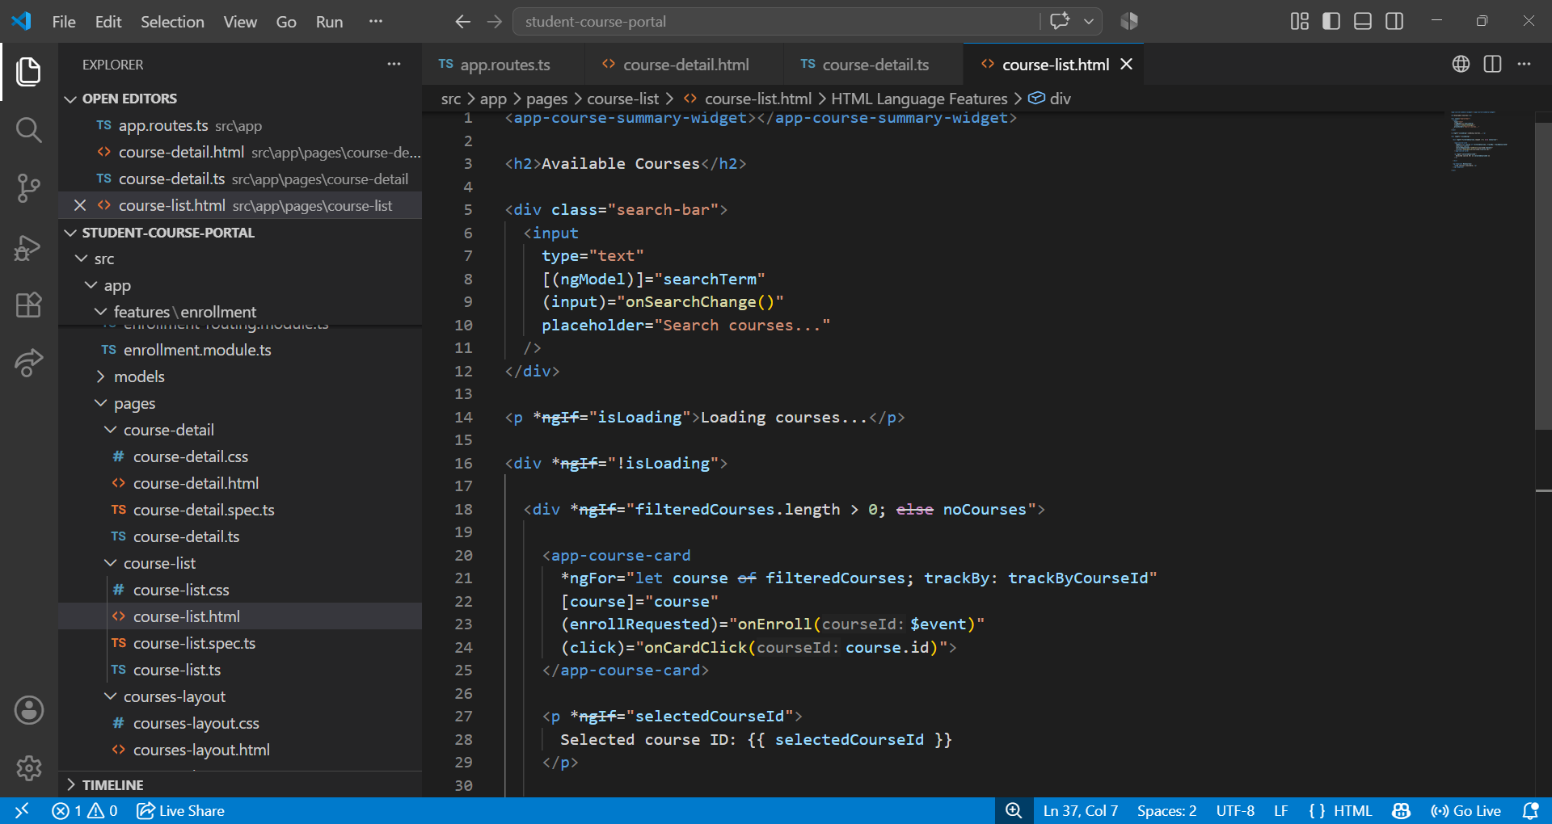
course-list.ts:
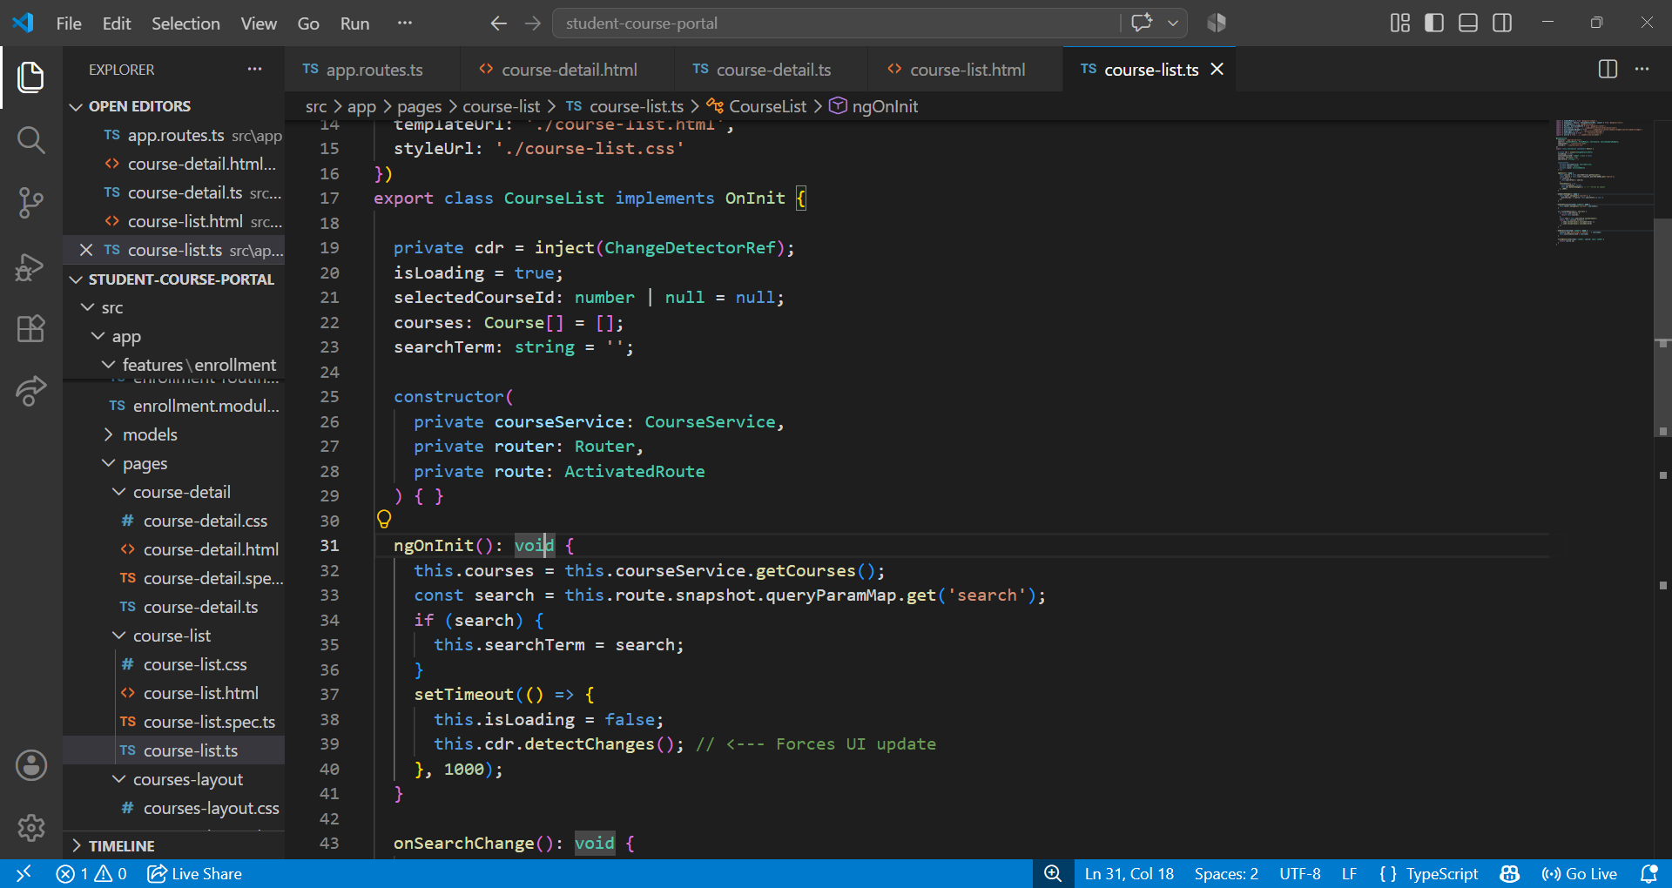

Searching the Course:
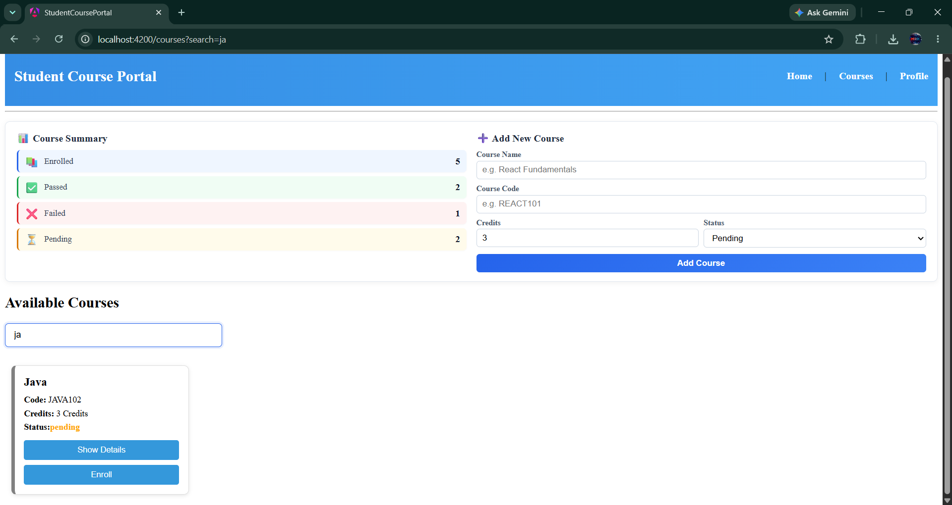
not-found.html:
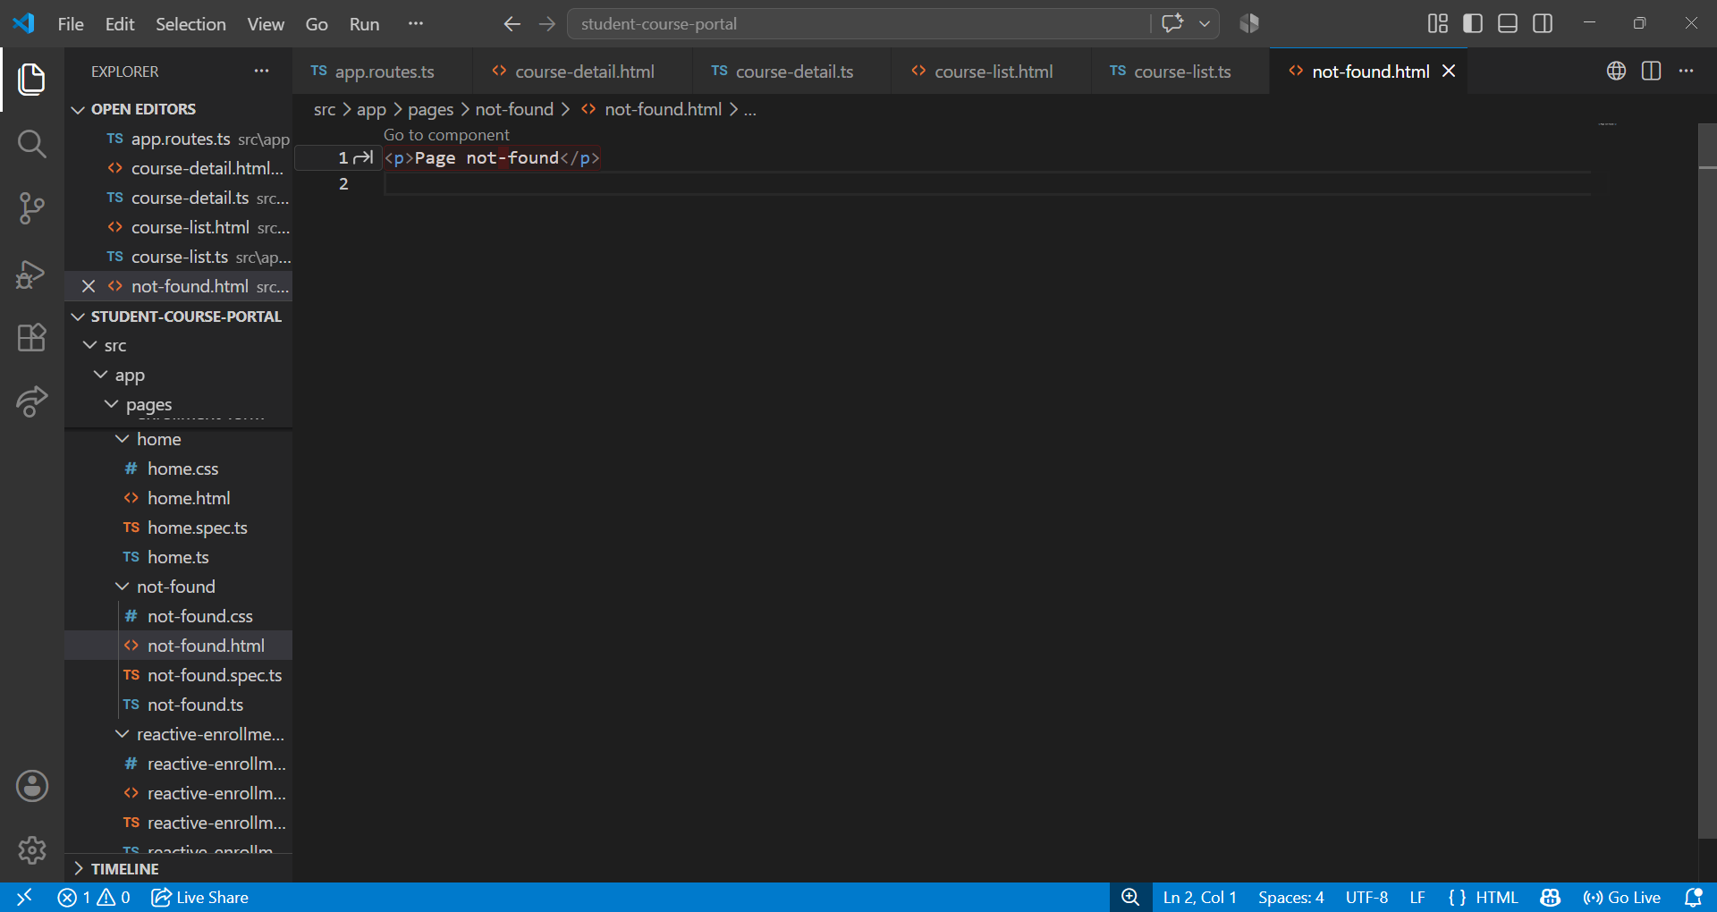

not-found.ts:
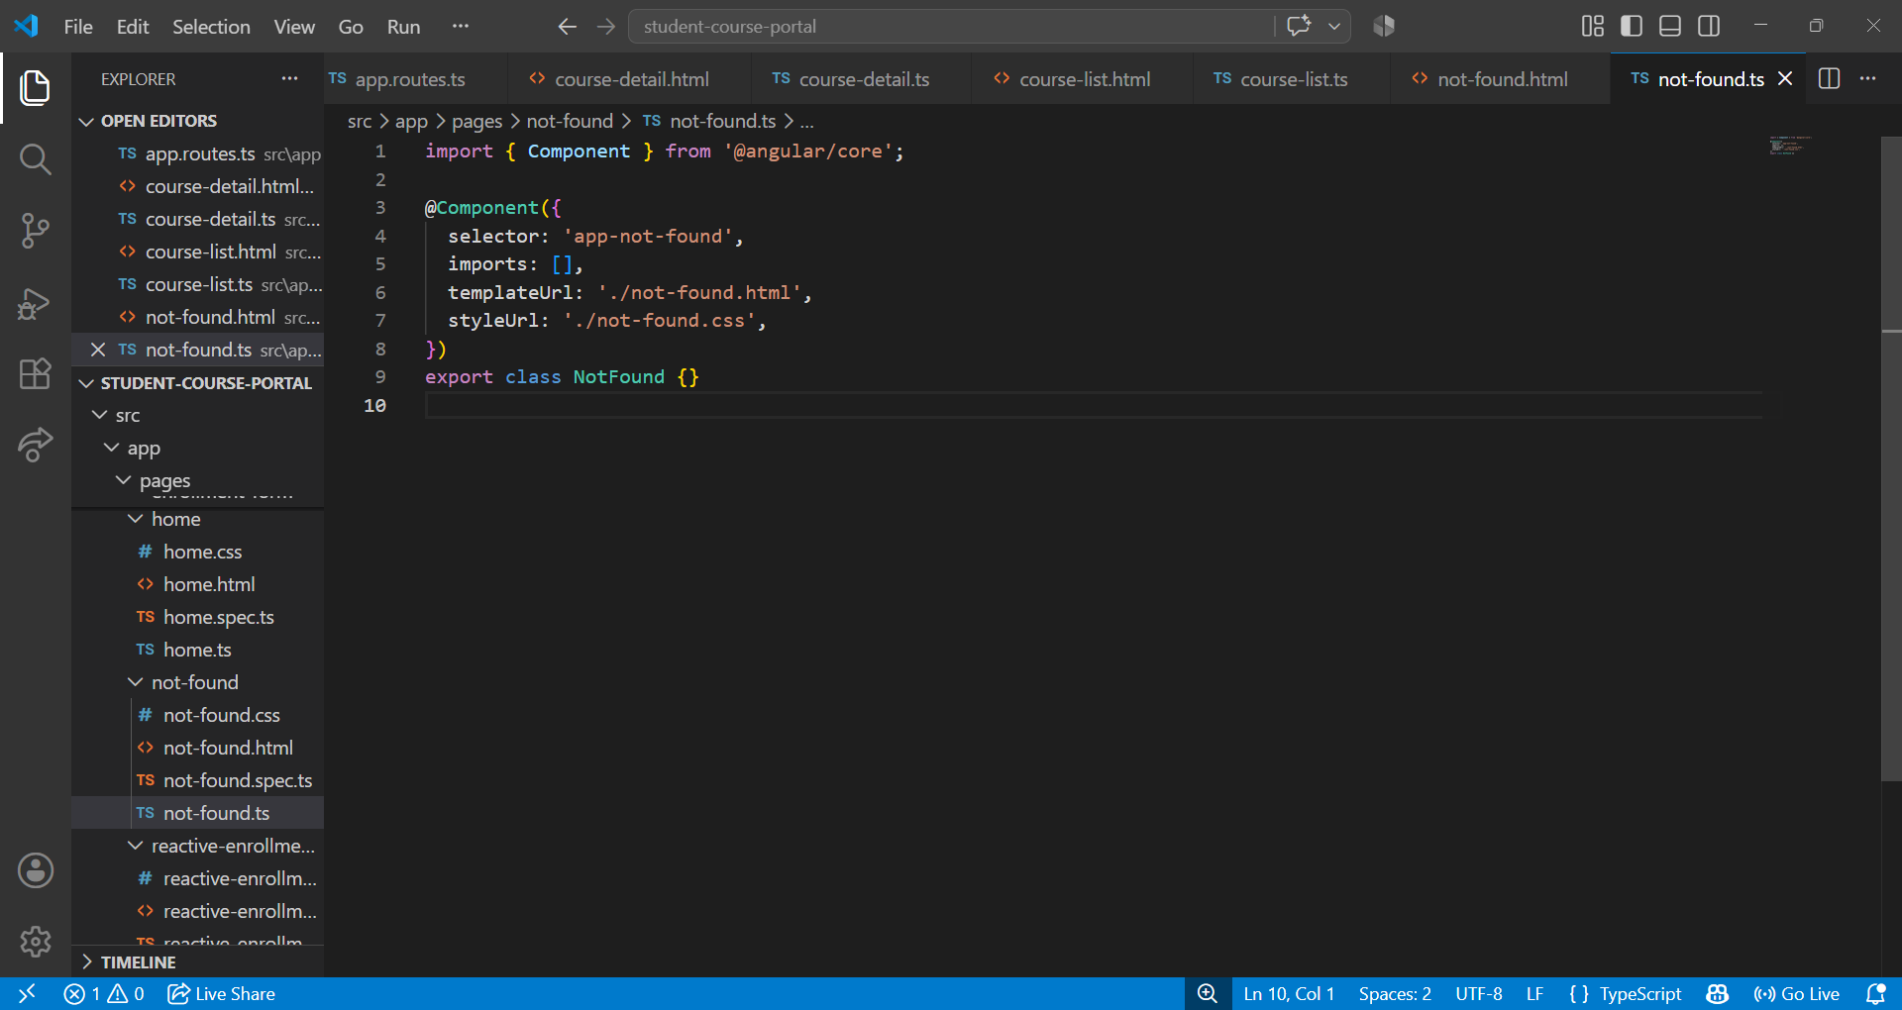
Not-Found Page displayed when Invalid URL entered:
Tried searching for /detail
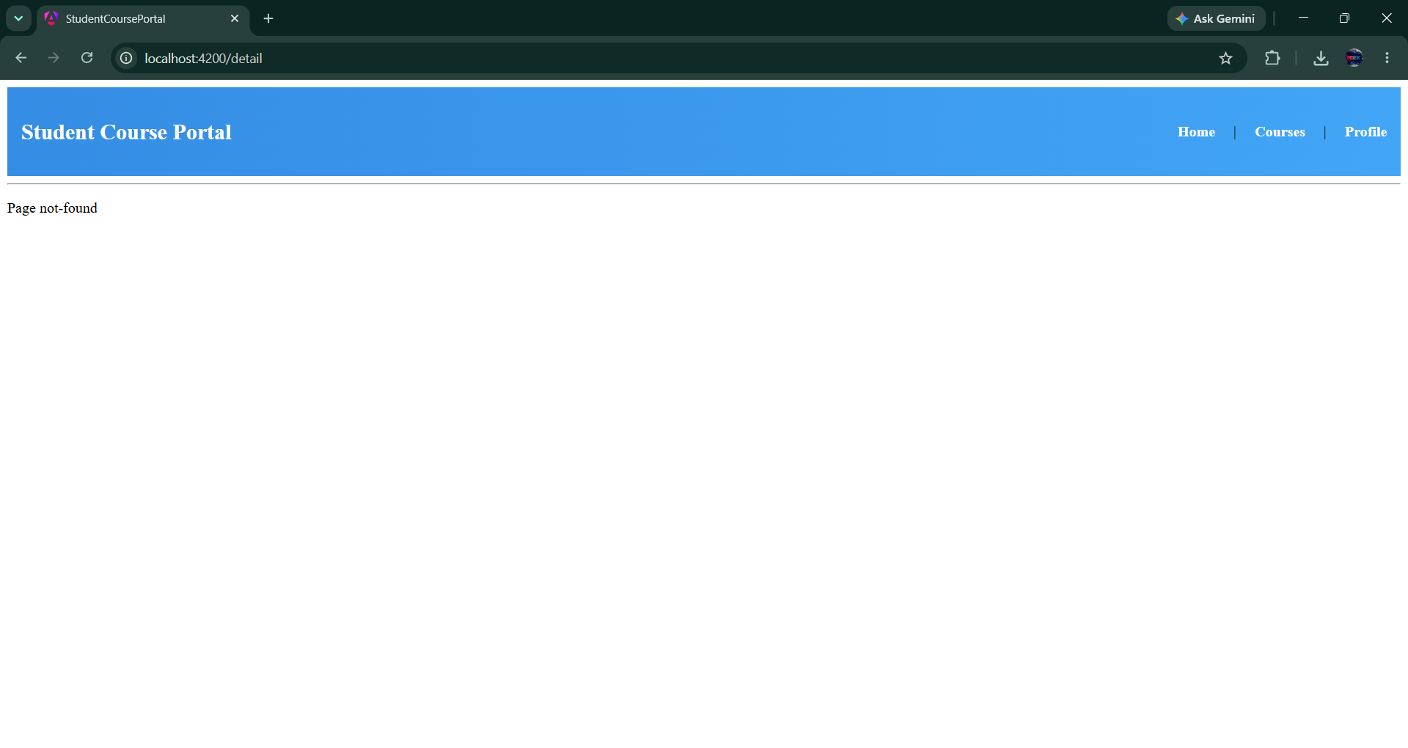

Task 2: Lazy Loading and Route Guards
Goal: Implement lazy loading for the enrollment feature and protect routes with guards.
enrollment-module.ts:
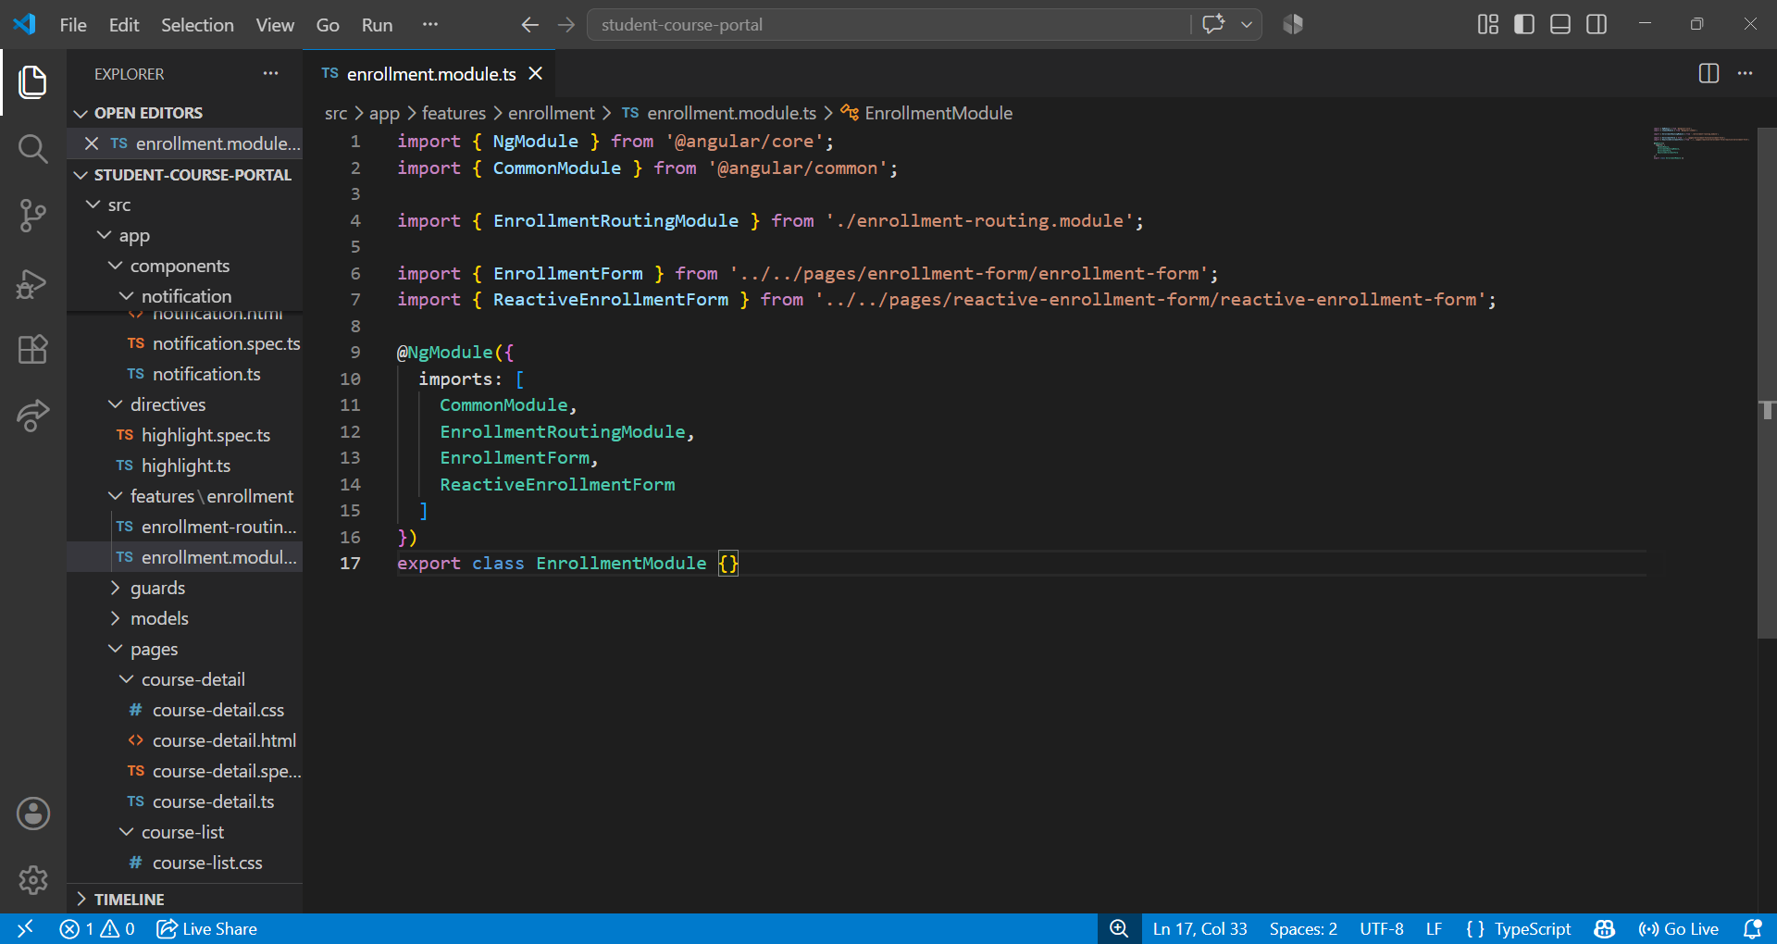
app.routes.ts:
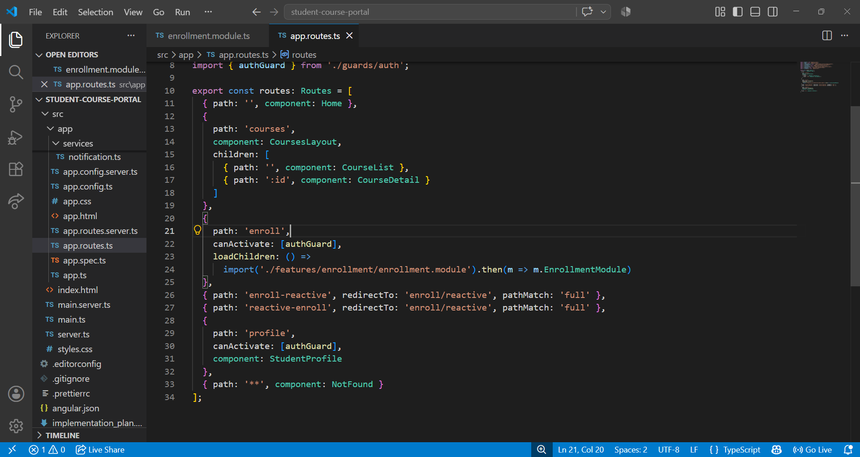

chunk files are downloaded when you visit /enroll:
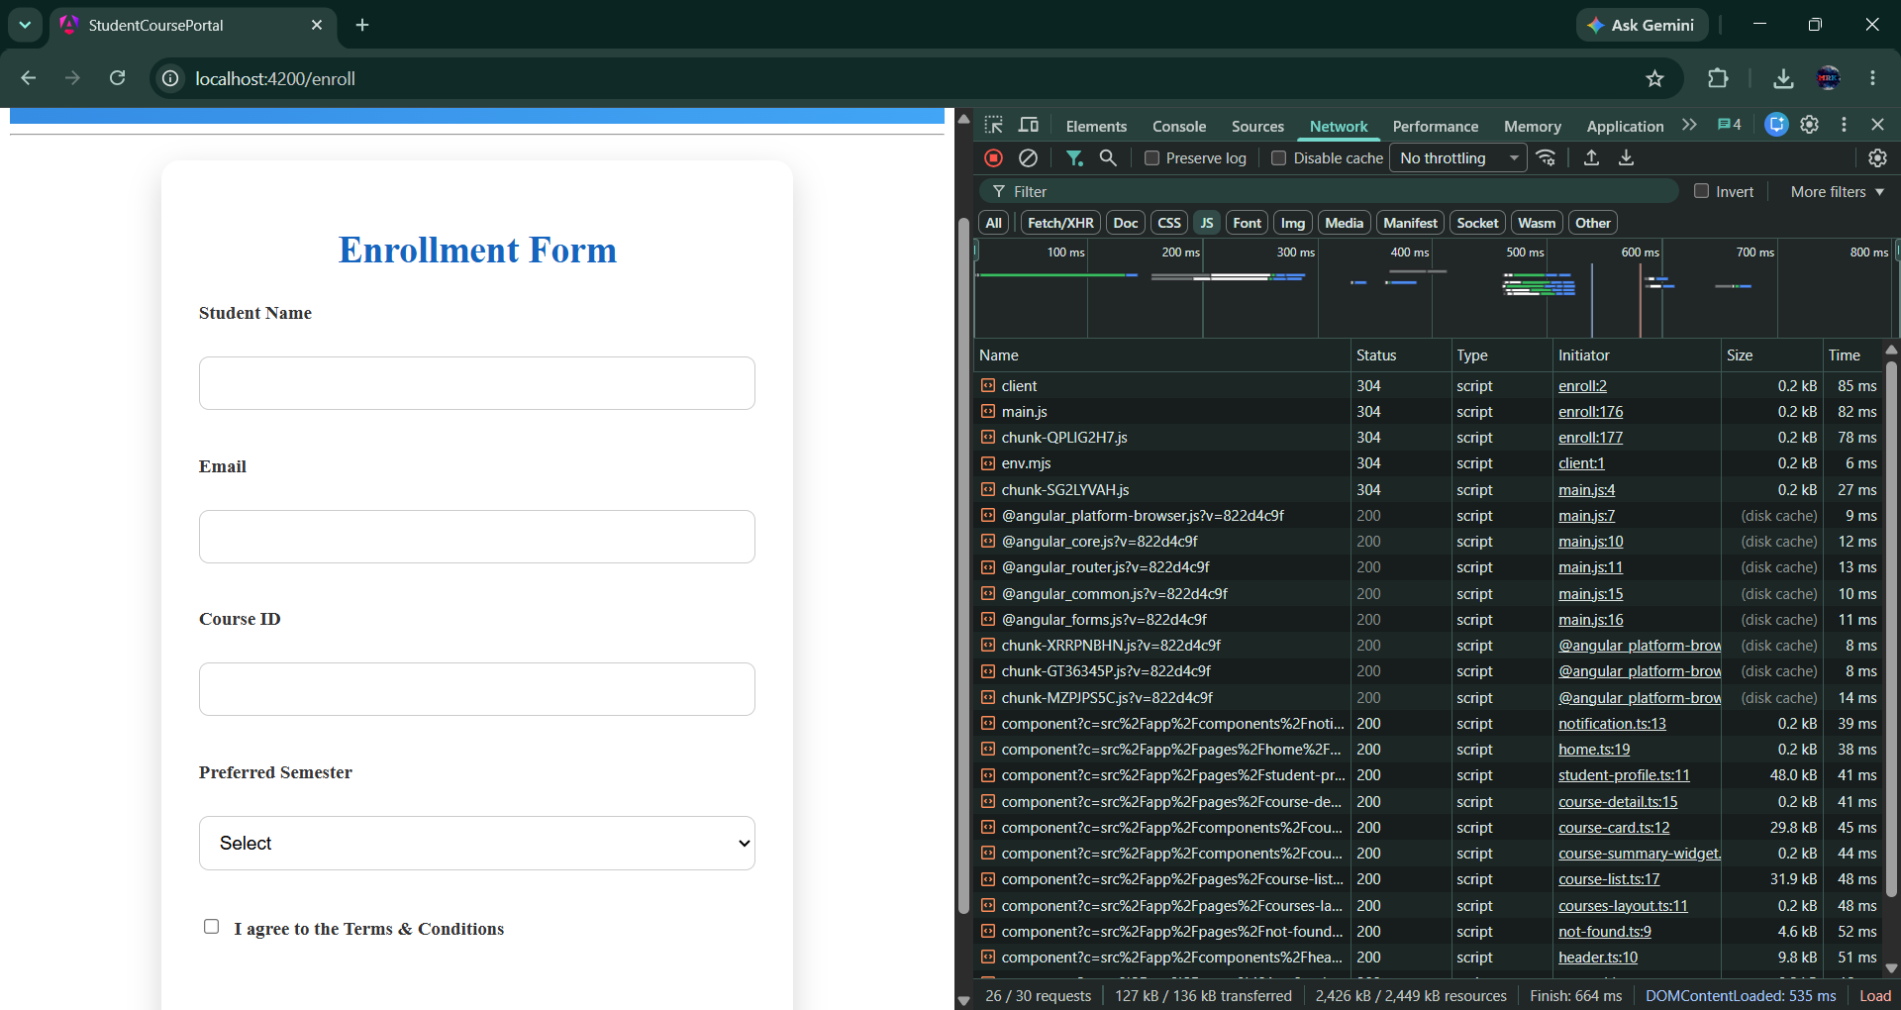
Generated guard and service:
app.routes.ts:
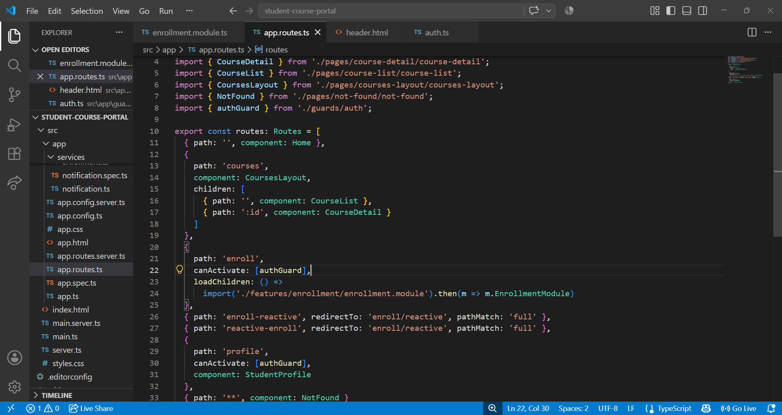

Auth.ts
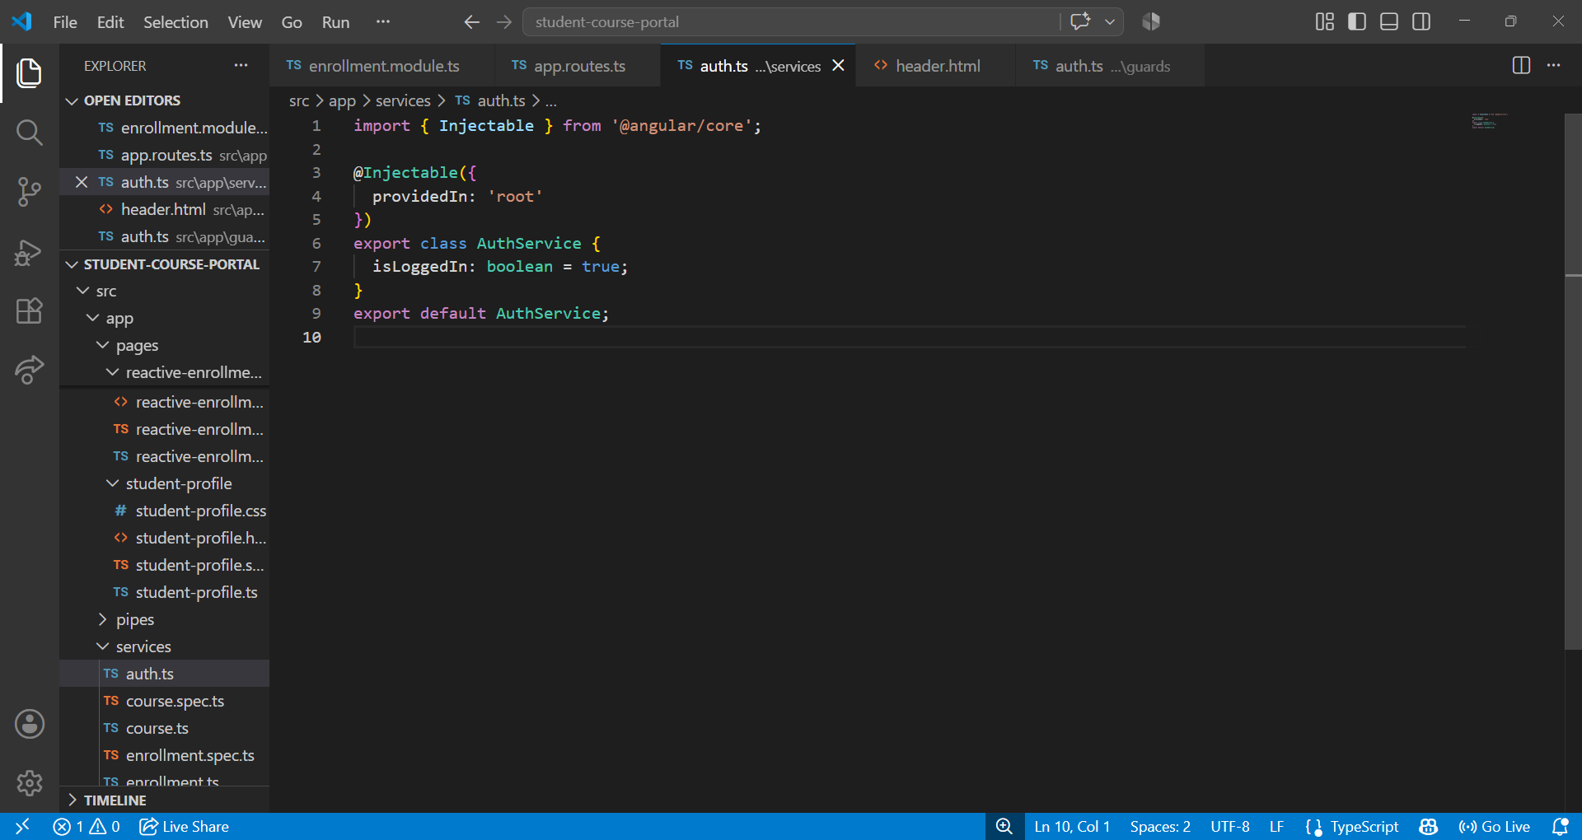
auth-guard.ts:
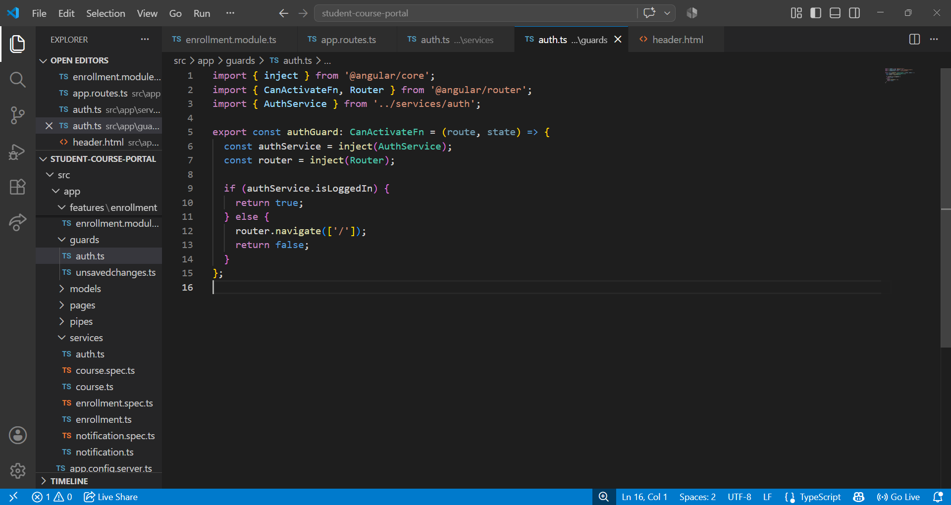

Redirect to the Home page when isLoggedIn = false:
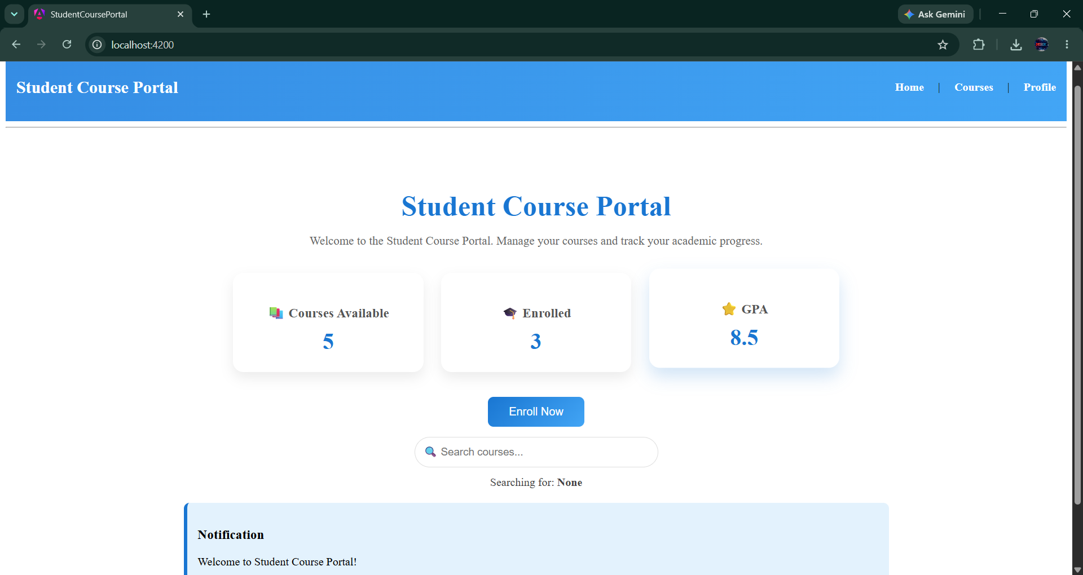
unsaved-changes-guard.ts:
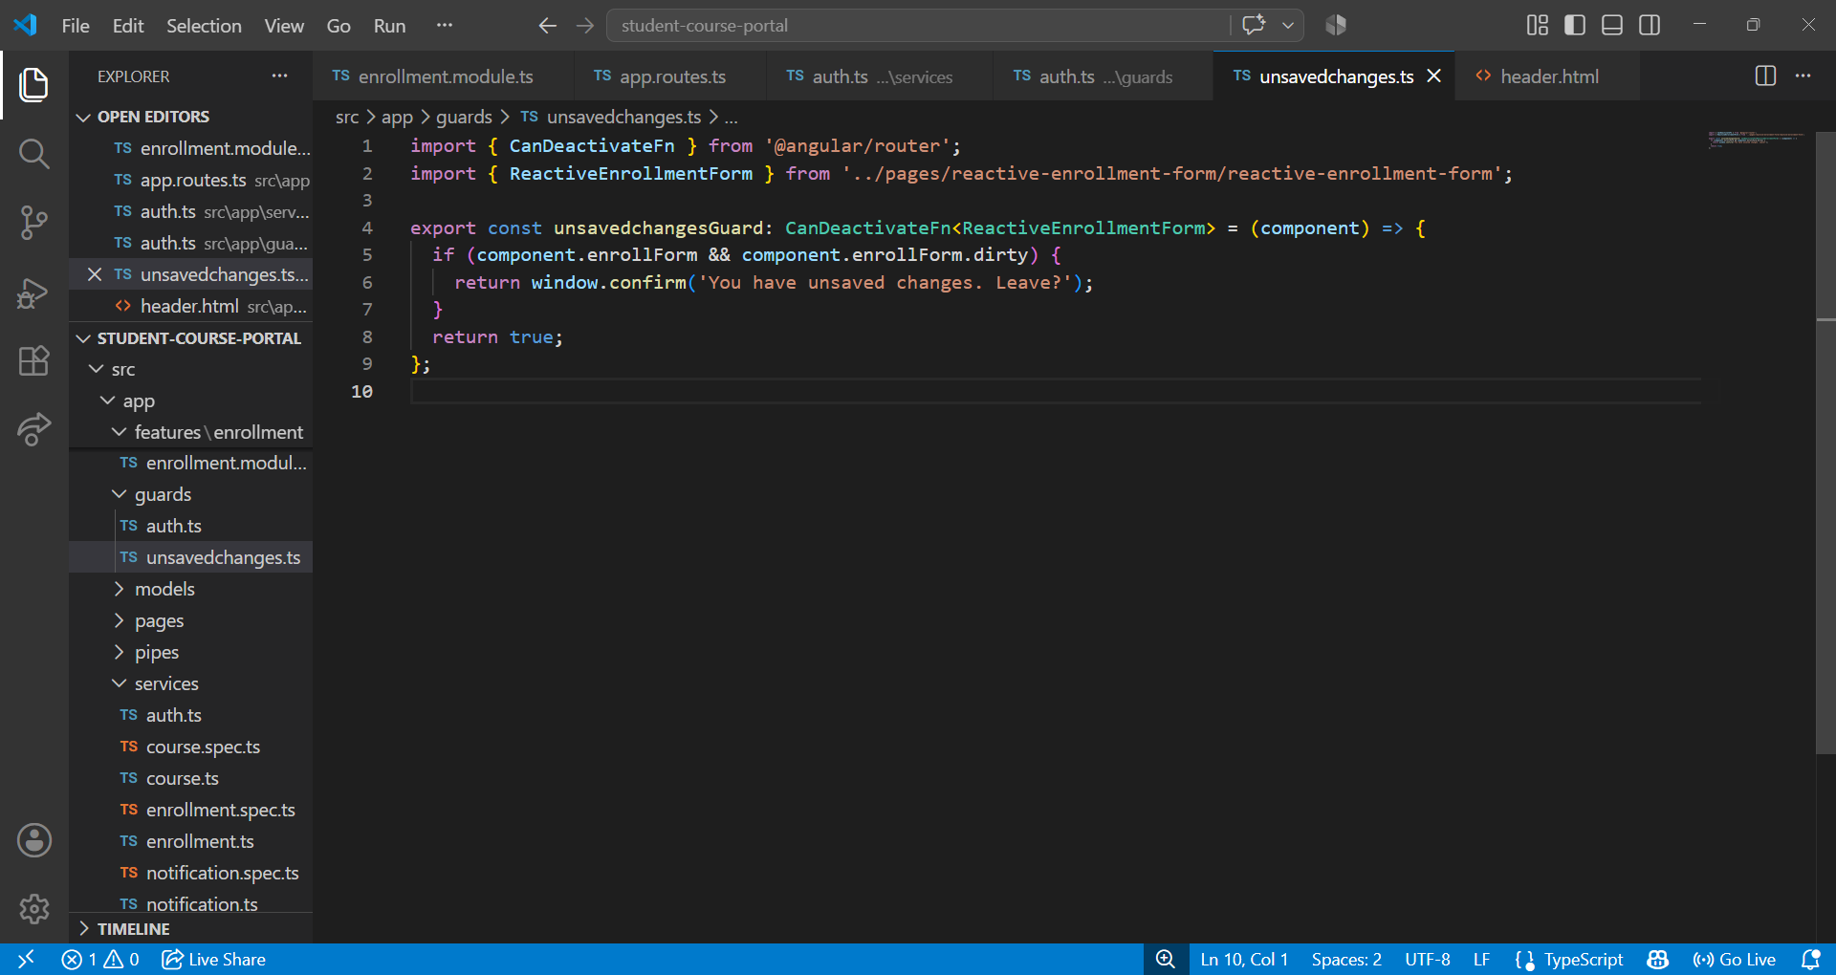

Confirmation dialog: "You have unsaved changes. Leave?”:
